In this assignment we were tasked with taking raw purchase data from a gaming company and break it out into useful informative chunks. In doing so I discovered a few interesting things.

1. The majority of players in the game are in fact male, but on average they spend less than the females. Knowing this, we could determine it may be more profitable to market toward female players.

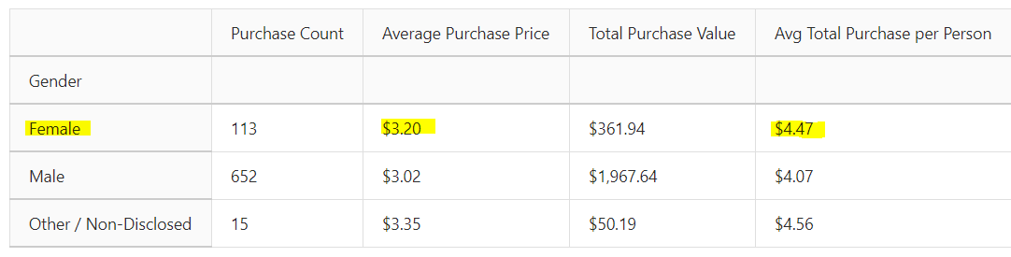

1. Although nearly 45% of gamers reside in the 20-24 age group, the big spenders exist in the 35-39 group. I recommend targeting this demographic to become more profitable.

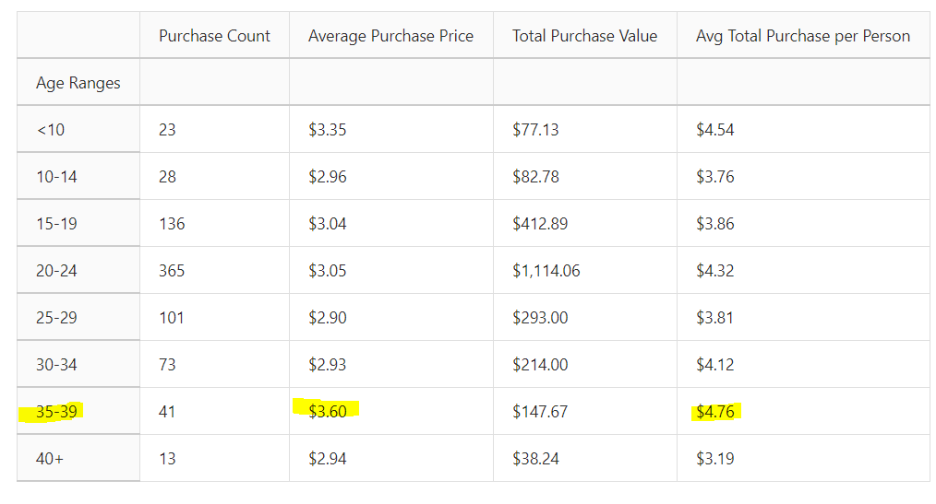

1. Lastly I noticed the item called “Final Critic” was both the leader in total number of purchases and overall purchase value. I recommend slowly raising the price on it to see if users will continue to buy it.

